Theresa Tracy Strive to Survive Online Auction – Orwig Auction
This auction will be held by Orwig Auction and Event Center. To register, go to: https://orwigauctionandeventcenter.hibid.com/catalog/285646/theresa-tracy-strive-to-survive-fundraiser/
- Click on Login / New Bidder at the top of the page
- Click on Register Here is new bidder. Enter user name and password if already registered.
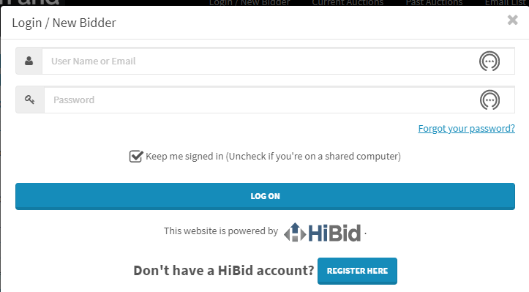
- To register, enter email address then click check email.
- Enter your information.
- Choose user ID and password and create new account.
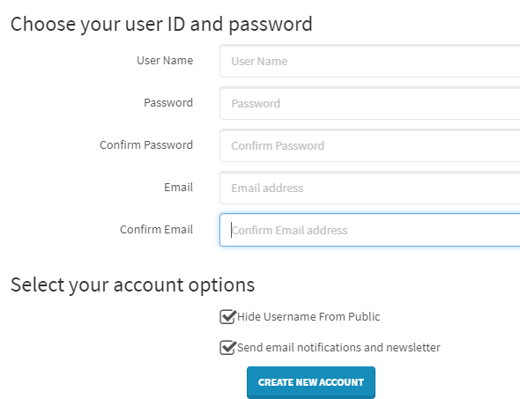
- Register to bid for Theresa Tracy Strive to Survive Fundraiser
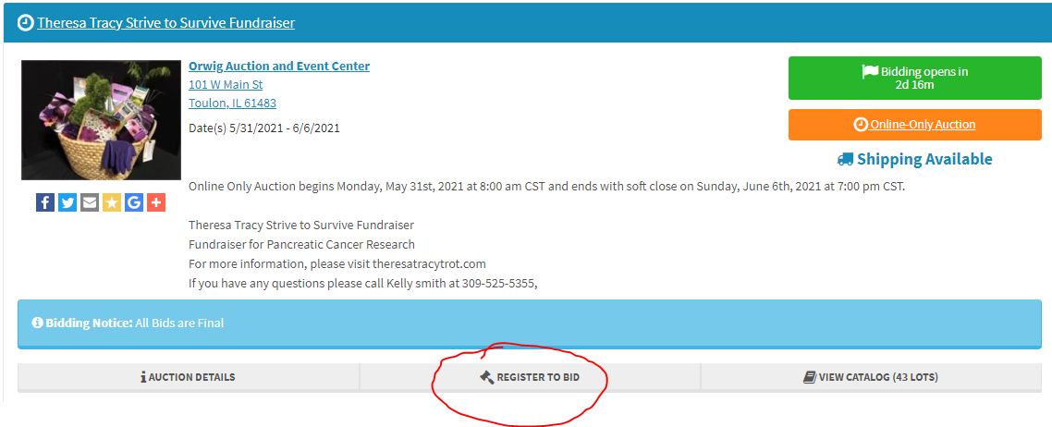
- You must register a credit card to bid on items. YOUR CREDIT CARD WILL NOT BE CHARGED IF YOU WIN BASKET. Instead, we will hold 2 pick up times (one in Toulon and one in East Peoria) after the auction ends. Payment will be collected at time of pick up.
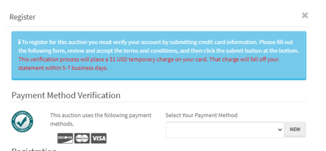

Happy bidding and thank you for your support!

